[ Insert official UPAEP logo ]
UPAEP · Decanato de Ingenierías
EVIDENCE — US16-T3
Build the irrigation parameters screen
SmartGreenAI: Cilantro Crop

1. Task information
Task ID | US16-T3
User Story | US-16 — Automatic irrigation according to predefined conditions
Sprint | Sprint 3 (2026-10-12 – 2026-10-30)
Week | Week 1 (carry-over, closed in Week 2)
Responsible | Oscar Abraham Talavera Nava
Peer reviewer | Vicente Rocha Alfaro
Planned / actual hours | 2.5 h / 3.5 h (variance recorded in the Sprint 3 burndown)
Completed on | October 19, 2026
Status | Done

2. Task description
Create the administrator screen for target moisture, maximum duration, cooldown, consecutive readings, minimum tank level and enable/disable per area, using the configuration API (US16-T2).

3. Completion conditions
✓ Condition 1: The screen saves the parameters through the API.
How it was verified: The screen saves the parameters through PUT /irrigation/config/AREA-1; the database holds the new value with the administrator and the date.
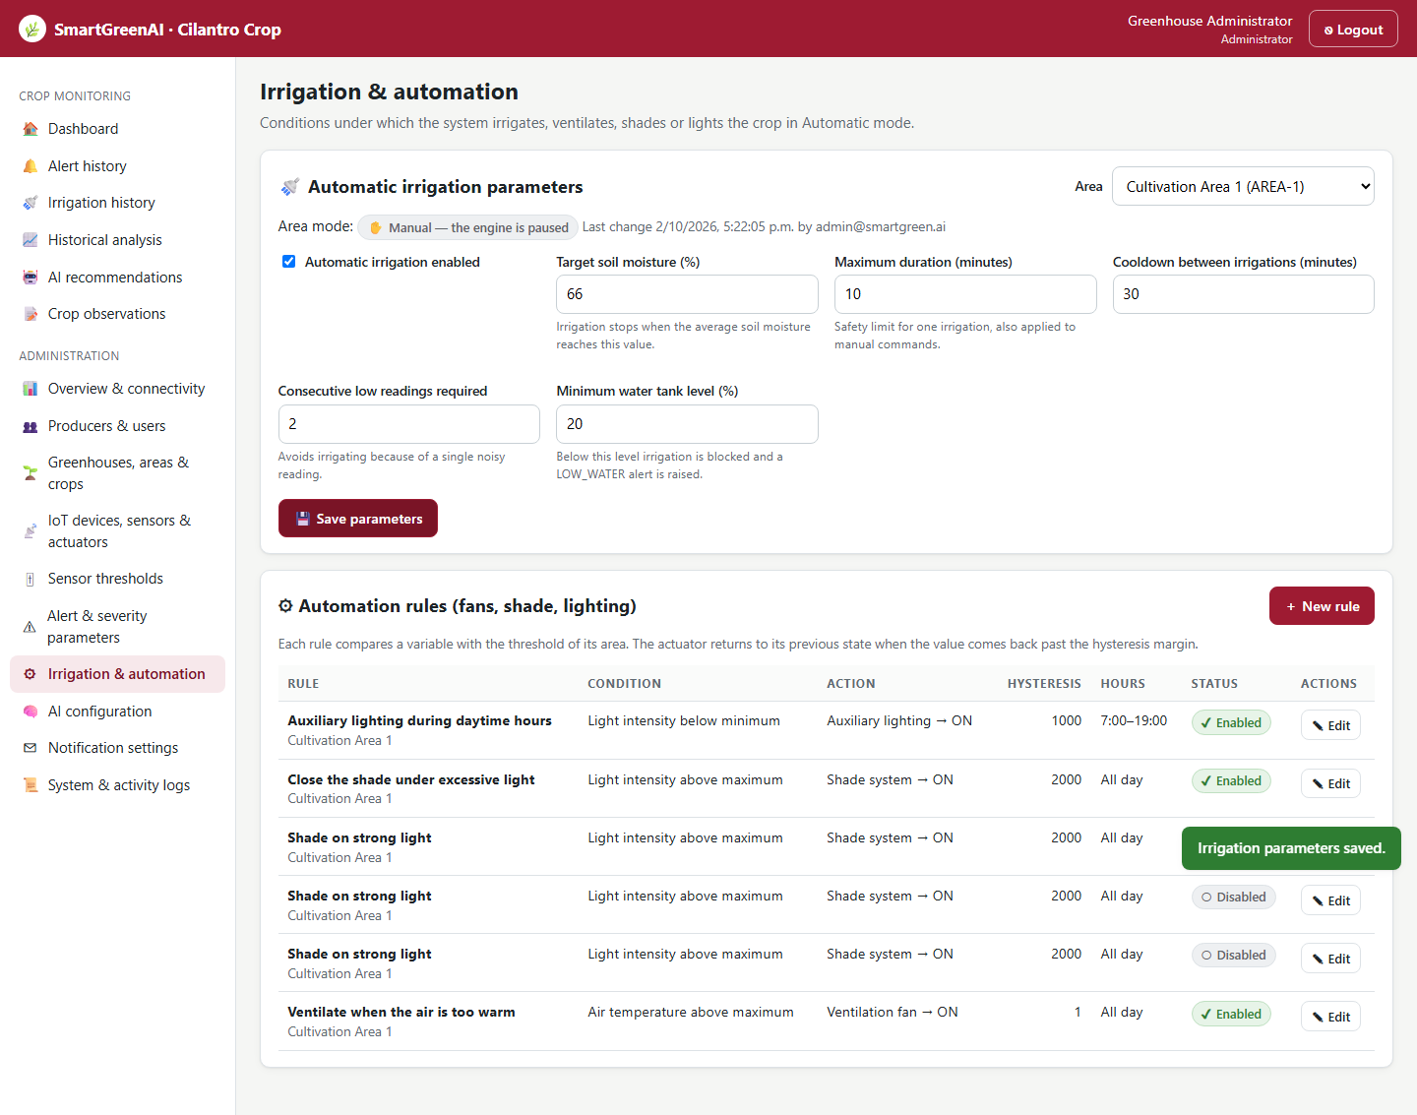
Figure US16-T3-1. Irrigation parameters screen after saving the target moisture 66 %. (US16-T3_Build_Irrigation_Parameters_Screen_1.png)
Values saved in the database (1 rows; US16-T3_Build_Irrigation_Parameters_Screen_2.csv)
area_id | enabled | target_moisture | max_duration_min | cooldown_min | consecutive_readings | min_tank_level | updated_by | updated_at
AREA-1 | true | 66 | 10 | 30 | 2 | 20 | admin@smartgreen.ai | 2026-09-29T04:42:09.493Z
SQL: SELECT c.area_id, c.enabled, c.target_moisture, c.max_duration_min, c.cooldown_min, c.consecutive_readings, c.min_tank_level, u.email AS updated_by, c.updated_at FROM irrigation_config c LEFT JOIN users u ON u.id = c.updated_by WHERE c.area_id = 'AREA-1'
✓ Condition 2: Invalid values are rejected.
How it was verified: Invalid values are rejected (400, 400, 400) and the screen shows the message.
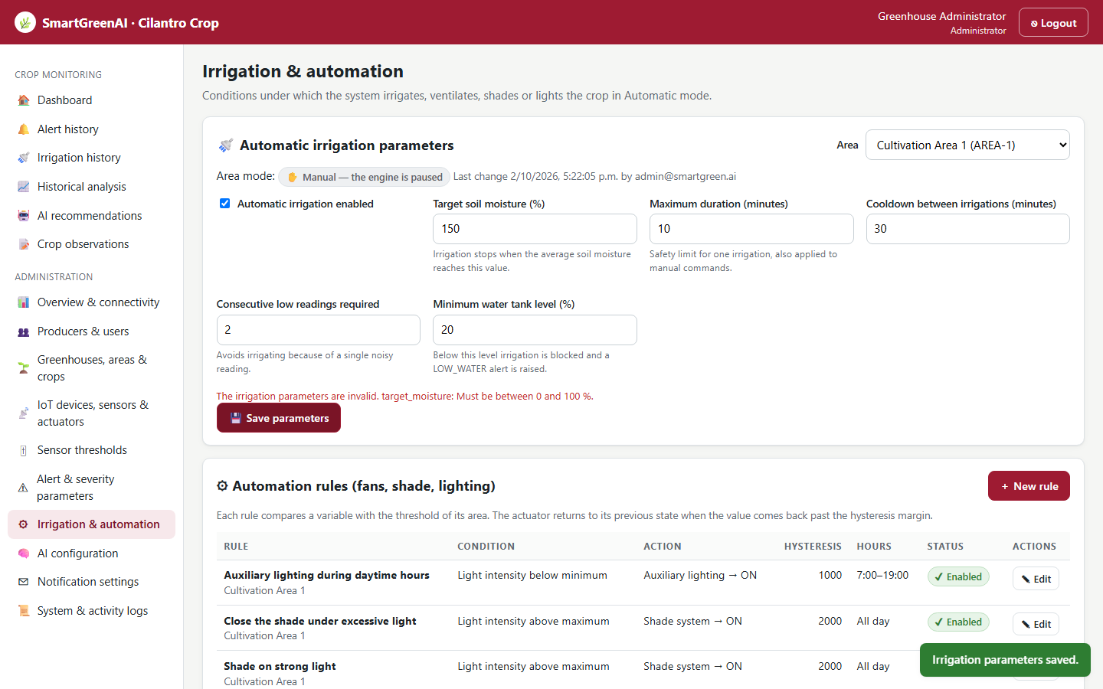
Figure US16-T3-2. An invalid value (target 150 %) is rejected with a message. (US16-T3_Build_Irrigation_Parameters_Screen_4.png)
Invalid values (attached: US16-T3_Build_Irrigation_Parameters_Screen_5.txt)
PUT /api/irrigation/config/AREA-1
Authorization: Bearer eyJhbG…
{
"target_moisture": 150
}
→ HTTP 400 Bad Request (17 ms)
{
"status": 400,
"code": "ERR_VALIDATION_FAILED",
"message": "The irrigation parameters are invalid.",
"details": [
{
"field": "target_moisture",
"issue": "Must be between 0 and 100 %."
}
]
… (1 more lines in the attached file)
PUT /api/irrigation/config/AREA-1
Authorization: Bearer eyJhbG…
{
"max_duration_min": 0
}
→ HTTP 400 Bad Request (16 ms)
{
"status": 400,
"code": "ERR_VALIDATION_FAILED",
"message": "The irrigation parameters are invalid.",
"details": [
{
"field": "max_duration_min",
"issue": "Must be greater than zero."
}
]
… (1 more lines in the attached file)
PUT /api/irrigation/config/AREA-1
Authorization: Bearer eyJhbG…
{
"consecutive_readings": 0
}
→ HTTP 400 Bad Request (13 ms)
{
"status": 400,
"code": "ERR_VALIDATION_FAILED",
"message": "The irrigation parameters are invalid.",
"details": [
{
"field": "consecutive_readings",
"issue": "Must be at least 1."
}
]
… (1 more lines in the attached file)

✓ Condition 3: Only administrators can modify them.
How it was verified: Only administrators can modify them: the Producer receives 403. The target was restored to 65 % after the test.
Producer attempt (attached: US16-T3_Build_Irrigation_Parameters_Screen_6.txt)
PUT /api/irrigation/config/AREA-1
Authorization: Bearer eyJhbG…
{
"target_moisture": 70
}
→ HTTP 403 Forbidden (11 ms)
{
"status": 403,
"code": "ERR_INSUFFICIENT_PERMISSIONS",
"message": "Your role (Producer) does not allow this operation.",
"details": [
{
"field": "permission",
"issue": "Missing permission: irrigation.write"
}
]
}

✓ Condition 4: Evidence: Screenshot of the screen and the saved values in the database.
How it was verified: Screenshot of the screen and the saved values in the database.

4. Attached files
- US16-T3_Build_Irrigation_Parameters_Screen_1.png
- US16-T3_Build_Irrigation_Parameters_Screen_2.csv
- US16-T3_Build_Irrigation_Parameters_Screen_3.sql
- US16-T3_Build_Irrigation_Parameters_Screen_4.png
- US16-T3_Build_Irrigation_Parameters_Screen_5.txt
- US16-T3_Build_Irrigation_Parameters_Screen_6.txt

5. Traceability
Related requirements | FR-18, NFR-08
Implementation | public/admin/automation.html, public/js/pages/automation.js
Verification | screenshot

6. Sign-off
Role | Name | Date | Signature
Responsible | Oscar Abraham Talavera Nava | October 19, 2026
Peer reviewer | Vicente Rocha Alfaro | October 19, 2026
Product Owner acceptance | Alexis Enrique Valle Parra | October 19, 2026
Approval record: Daily Meeting 2 of Sprint 3 (Monday, October 19, 2026), team update, Oscar Abraham Talavera Nava: "Finish US16-T3 and upload its evidence." Daily Meeting 3 of Sprint 3 (Monday, October 26, 2026), Scrum board: "Tasks moved to Done last week: US11-T3, US11-T4, US11-T5, US12-T2, US13-T3, US15-T6, US15-T7, US16-T3, US16-T4, US17-T2, US19-T4, US19-T5, US19-T6."

